User Manual – Test Case

Topic: Online Retail Application

Swim Wear a E-Commerce online Shopping

A Web Application
Development Team: 404

Member:
Đỗ Hùng Cường
Nguyễn Duy Vinh
Lê Thị Minh Phương
Nguyễn Thị Thủy Tiên
Lưu Minh Tín
Nguyễn Hồng Hà

Table of Contents

Introduction………………………………………………………………………………….. 2
Getting Started…………………………………………………………………………..…… 5
Running System…………………………………………………………………………..….. 6
Using System…………………………………………………………………………..……… 7
Test Case……………………………………………………………………...……………..... 19
Reference.…………………………………………………………………………………….. 34

Introduction

The document is written to guide the user how to use the system. This document will shows all the steps to running the system and displays some images for user to easily imagine the way using this website. Moreover, there are some test case included in this document that the tester had determined whether our web application, software system or any of its features is working effectively or not.

GETTING STARTED

-Start MySql connection for database
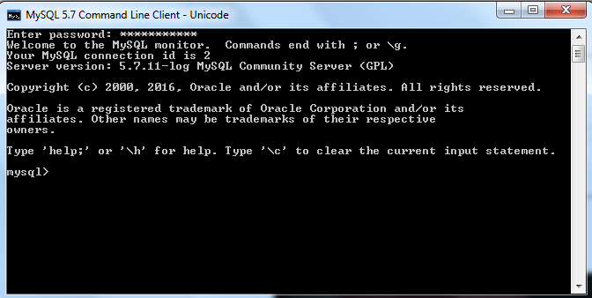

-Start Navicat and go to swimwearshop database connection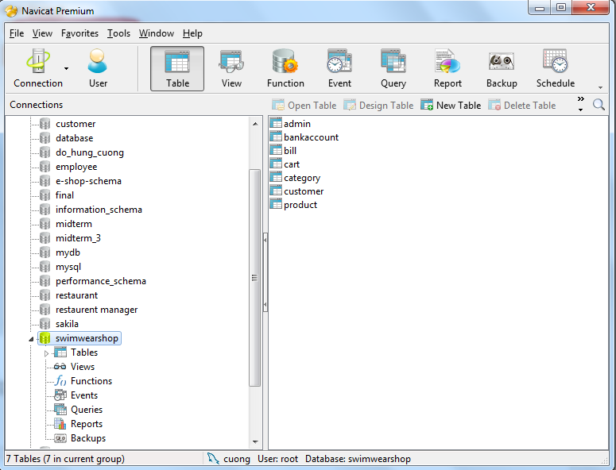

- Access web browser with correct link to run the project or use IDE such as Netbean to start running project

RUNNING SYSTEM

Customer interface
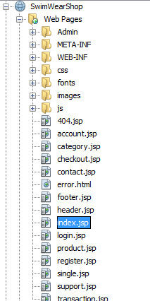

Admin system

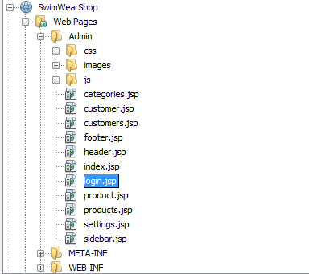

4.0 USING THE SYSTEM (workflow)

Customer:
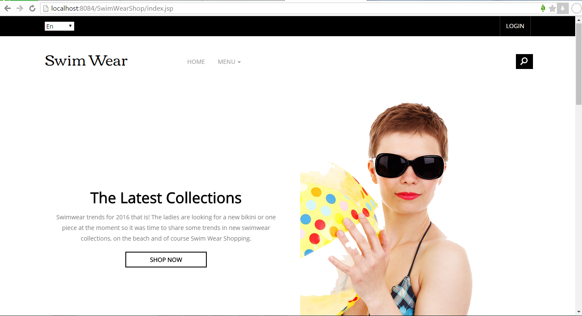

Welcome Firstly, access the homepage in Customer ‘s page, The system will display the Customer’s user interface in guest mode and the guest can only view the products in shop or search the products but they cannot add products to cart
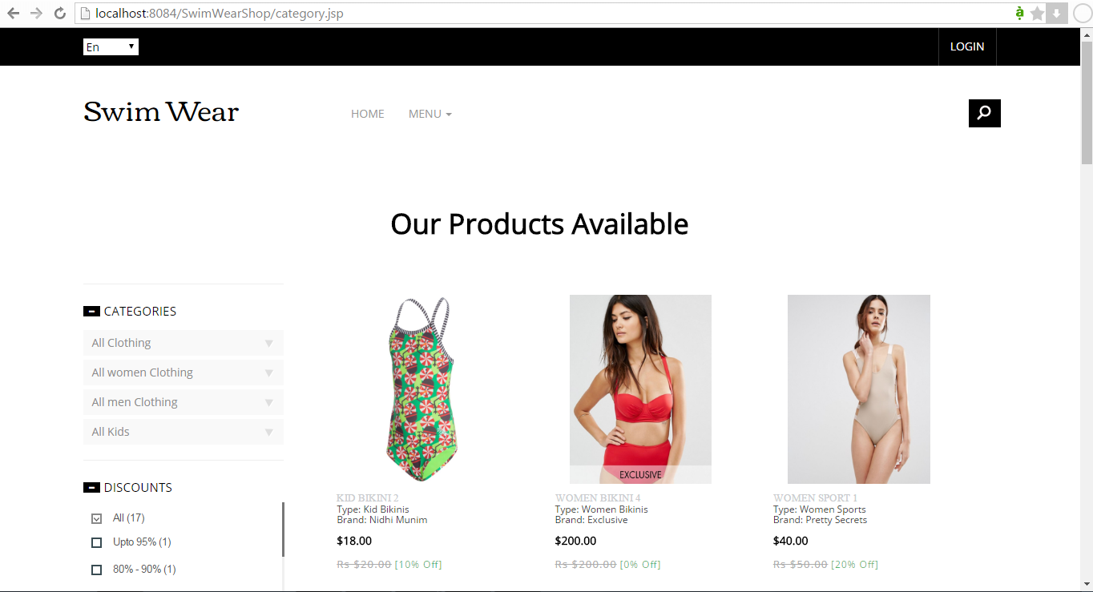

They can search product by input a Stirng and click search symbol button

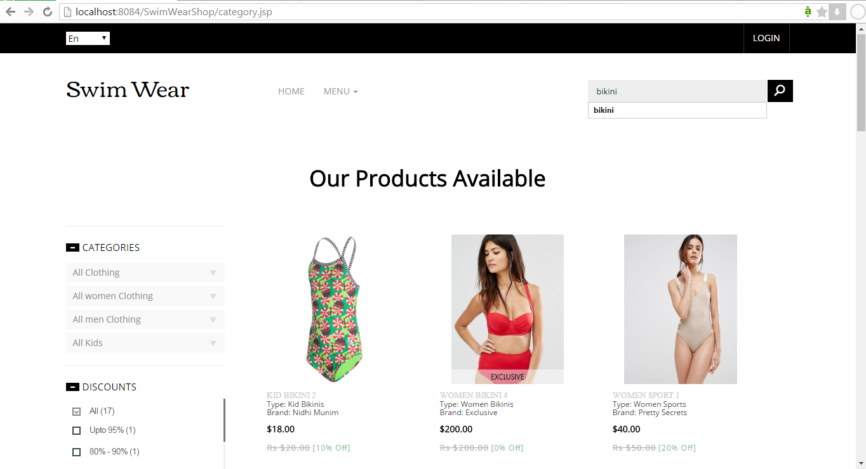

They can also search the product by discount, price, type, brand
They can click on a checkbox for searching the product with the discounts type, price are suitable with they checked, and they can aslo select the price from how many to how many by controling the “price” bar to find out the products they wish to buy.

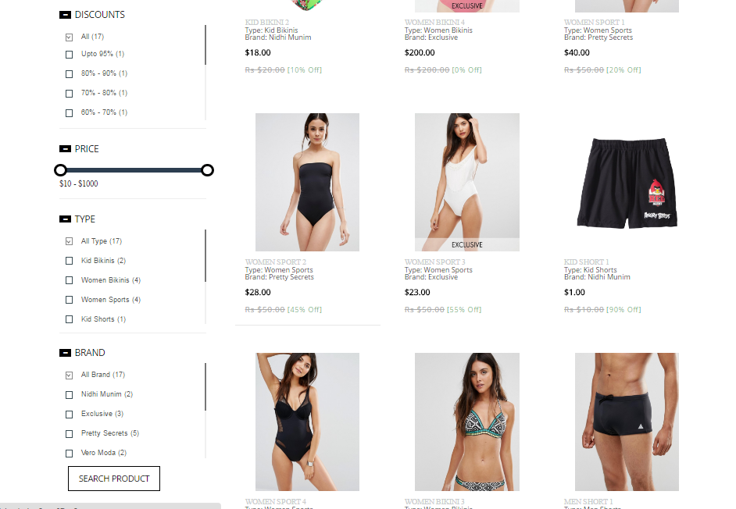

And the list of search value will be showed for guest/customer and also display message that how many result was found.

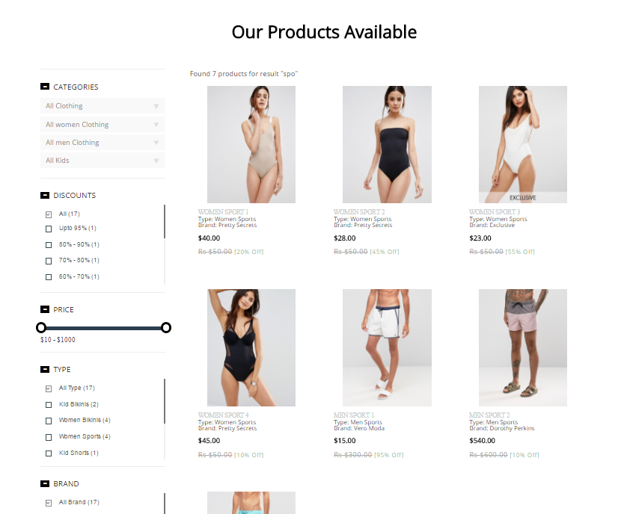

If customers want to order products, they have to create an account by access register.jsp page and input email, name, password, address, bank number, bank name, password and confirm the password.
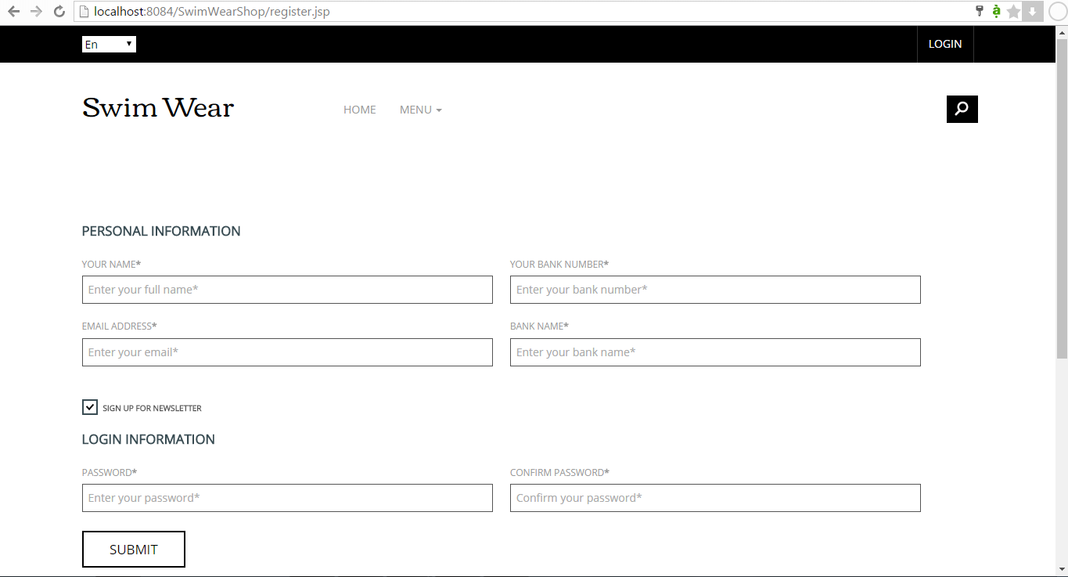

Then customers can login to the system.by using email and password of the account they created
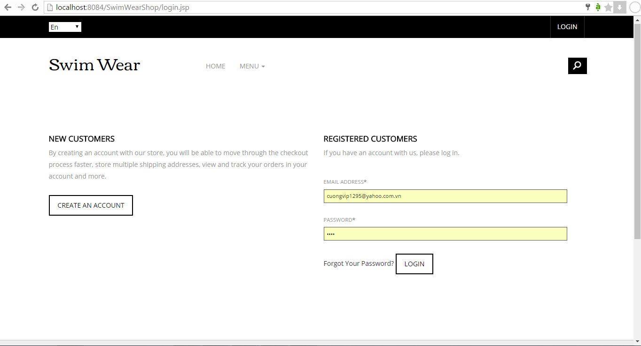

If customer had logged into system, then they can order product by selecting quantity or input a number in the textbox beside each product and clicking “+” button

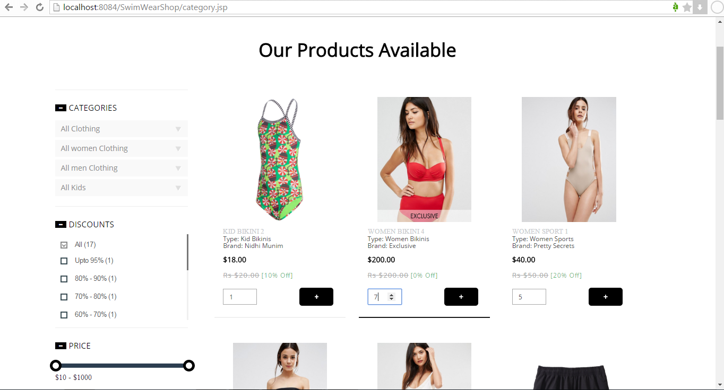

Then they can view their cart that contains the list of orders
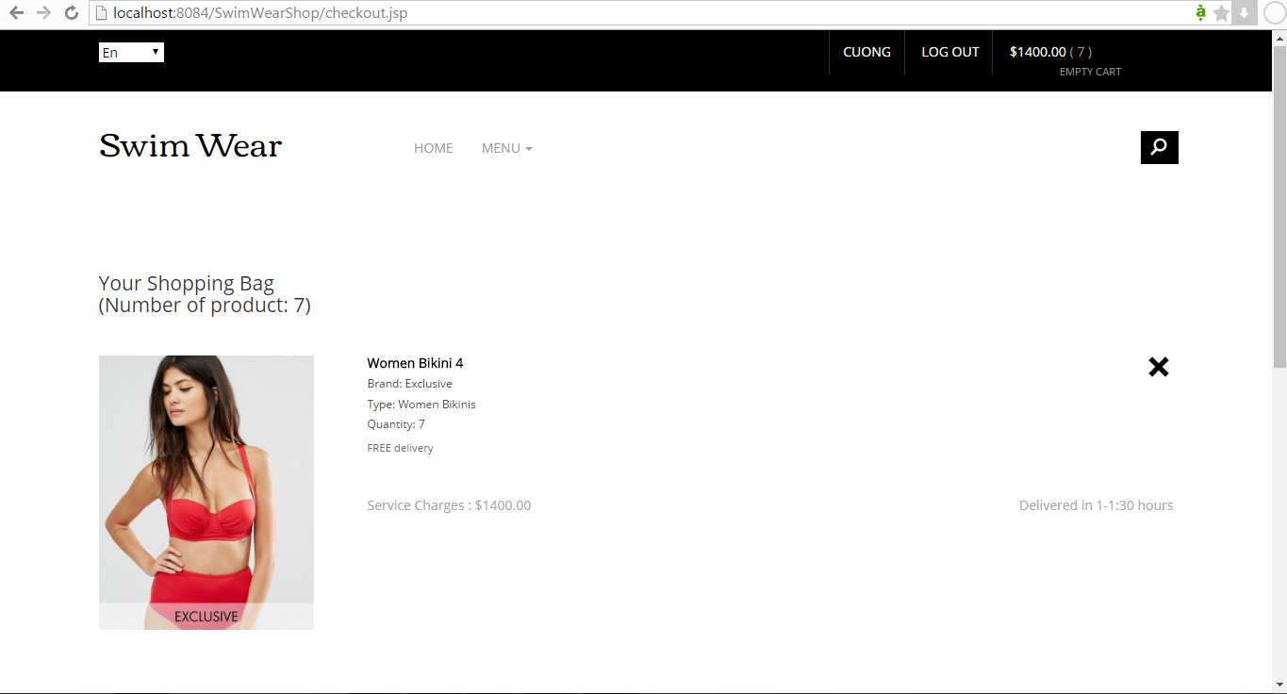

If customers pay for the the cart by clicking on button “Pay by bank account balance”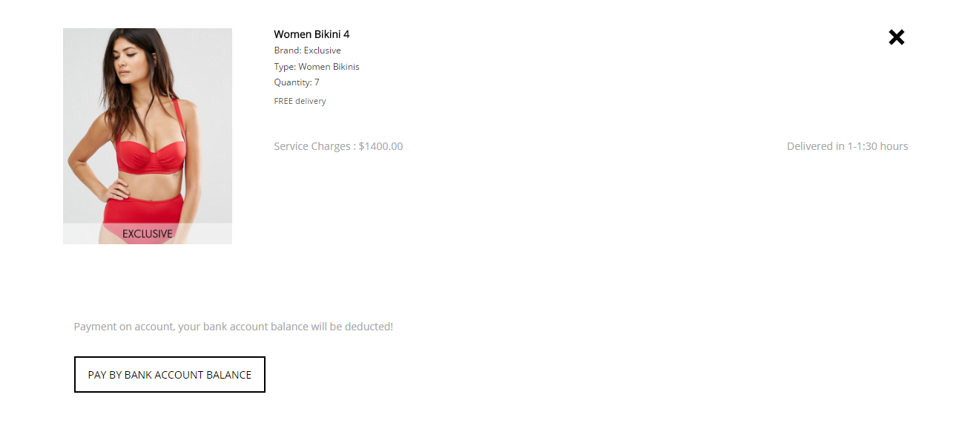

Then the system will compare the money in customer’account with the total cost of the cart then show the result that pay successfully or not

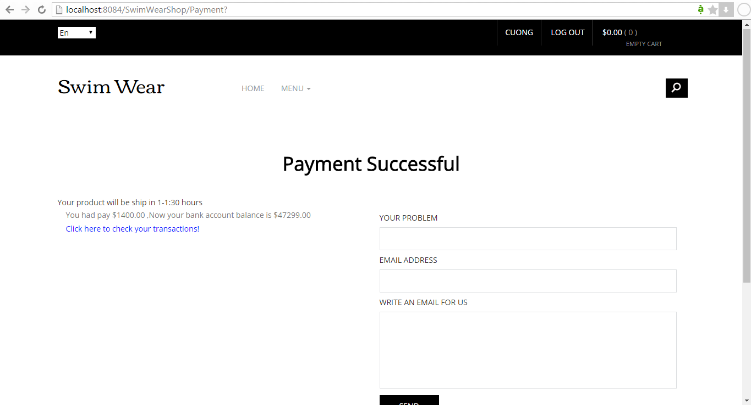

If the payment is successful, then customer can click on check your transaction, actually customers also can view transaction by click on the menu button at the header of the page and click “view transaction” link or at the footer of the page, Then the list of transaction will display for customers in transaction.jsp page

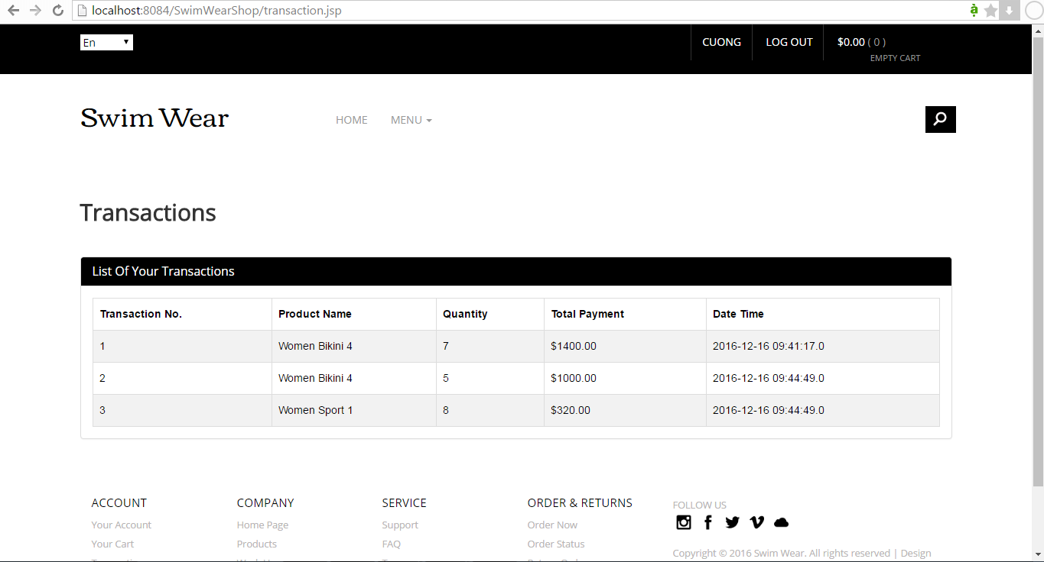

Customer can edit their profile by click on their profile account, customer can input information the edit and click on “edit information” button
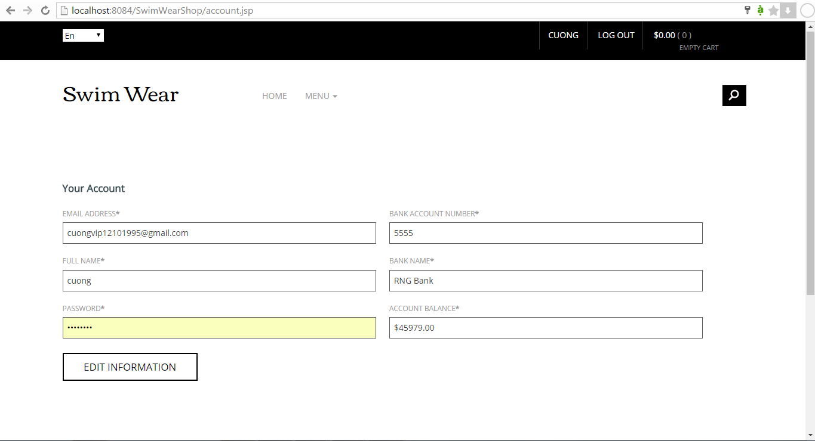
Then the system will display the new information for customer if edit successfully or show message that edit unsuccessfully

Administrator

Welcome Firstly, running the login.jsp in Admin ‘s page, The system will display the Admin user interface and the admin can only access the system by login to system.
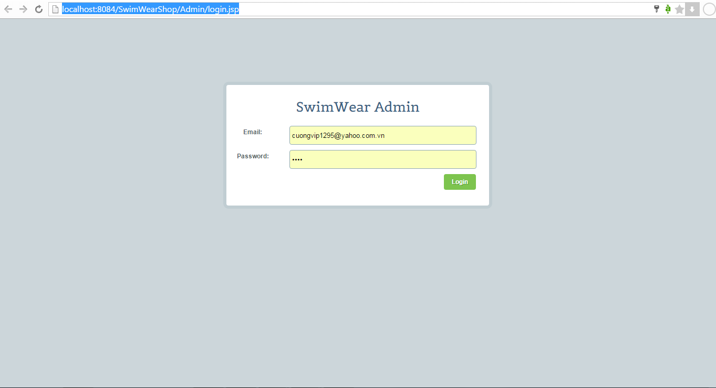

Then system will displays home page for admin ( index.jsp page )
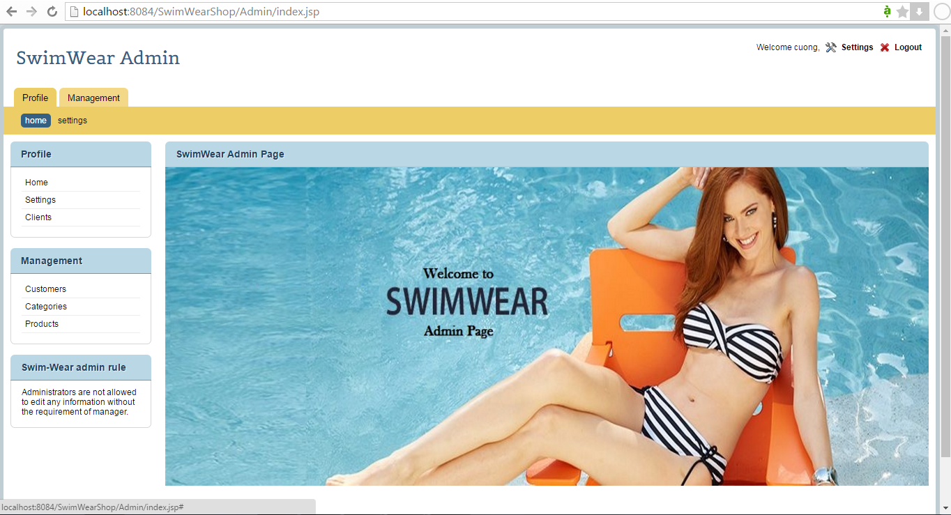

Admins can access setting page to edit something they want

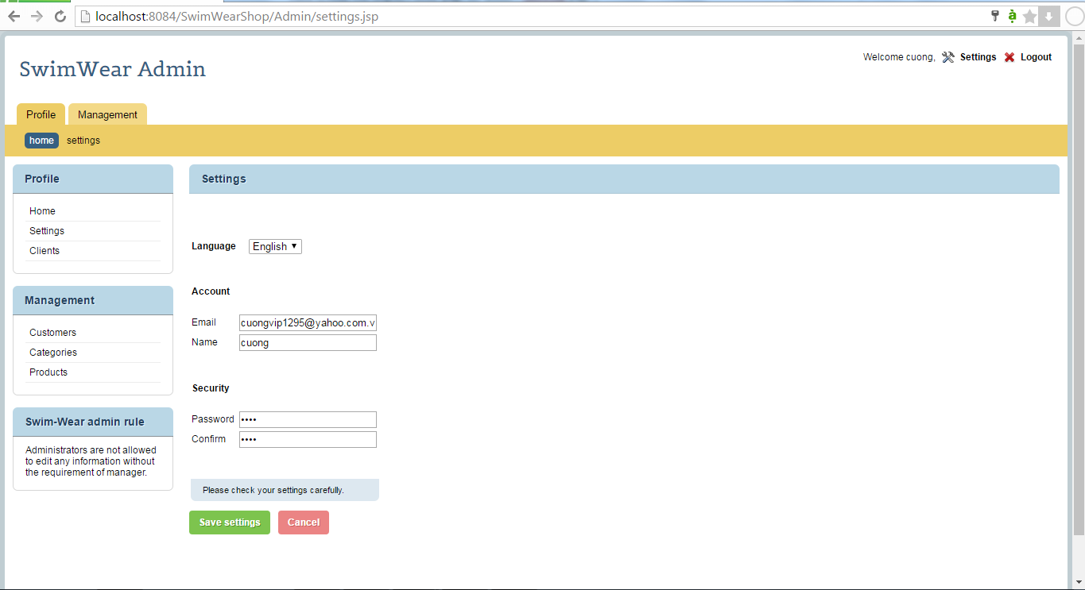

Admins can access customer page to manage the customers

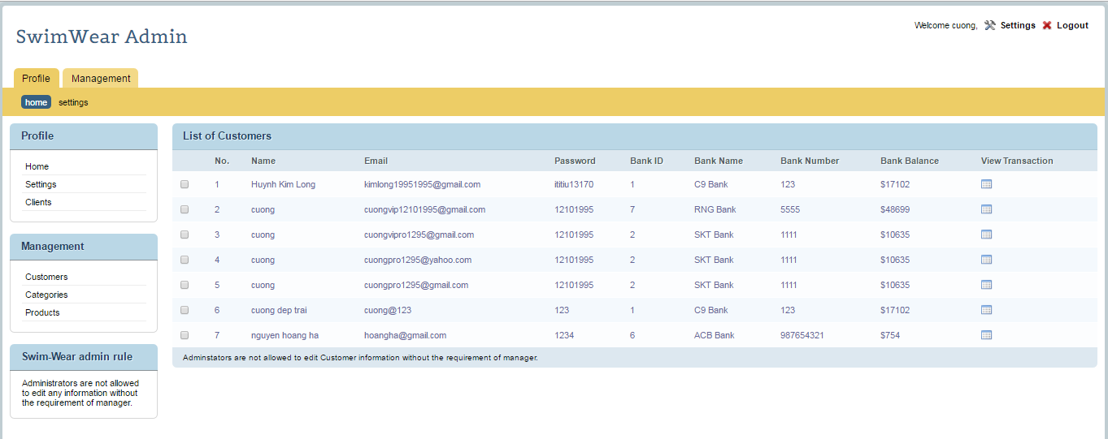

Admins can view customer’s transaction by click on symbol transaction button from the right of each column of the table that match with the one form each row.

Then the list of transaction is displayed for admin
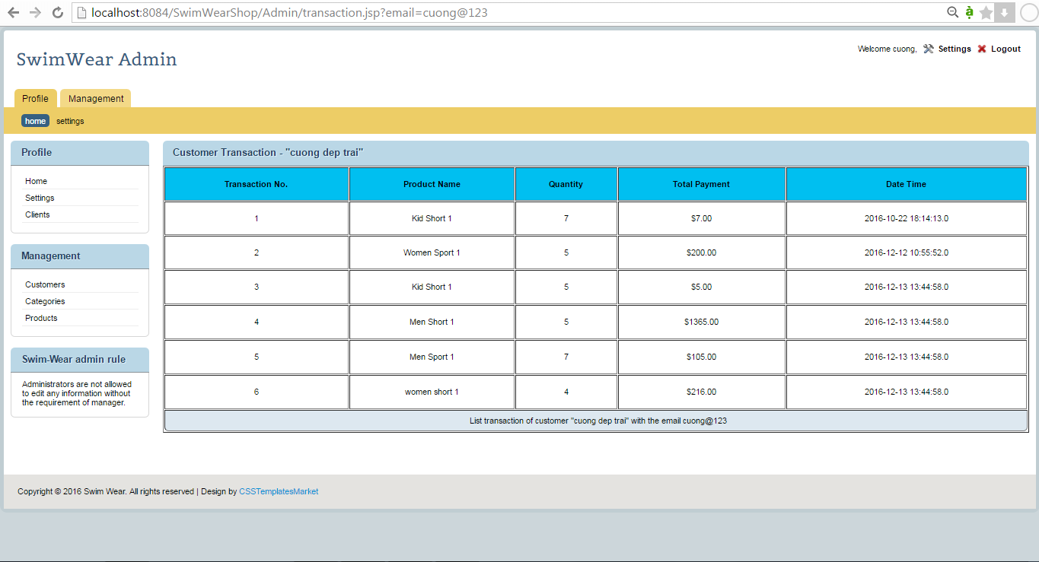

Admins can view products and their informations

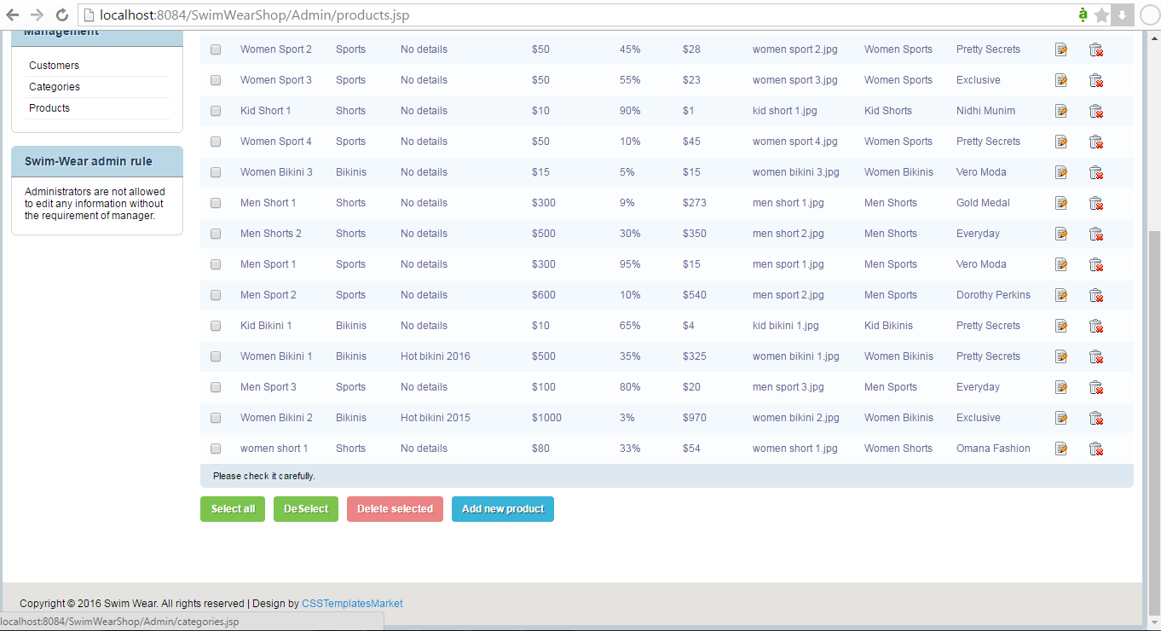

For easily to manage the products, admin can click on select all button to select all the checkbox that contains products or deselect them,and they can check any checkbox that they want to delect many products at one time.

Admins also can add new product, delete product or edit product information

Add new product
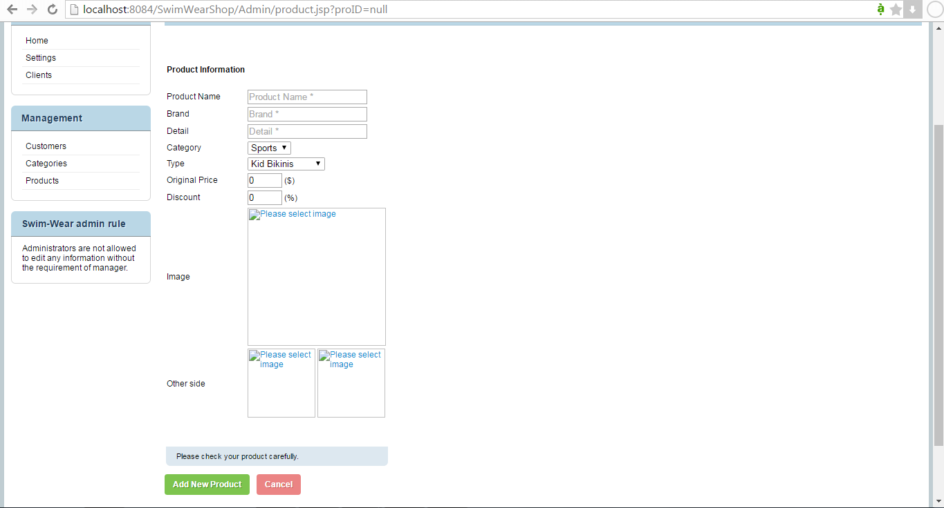

Edit product information
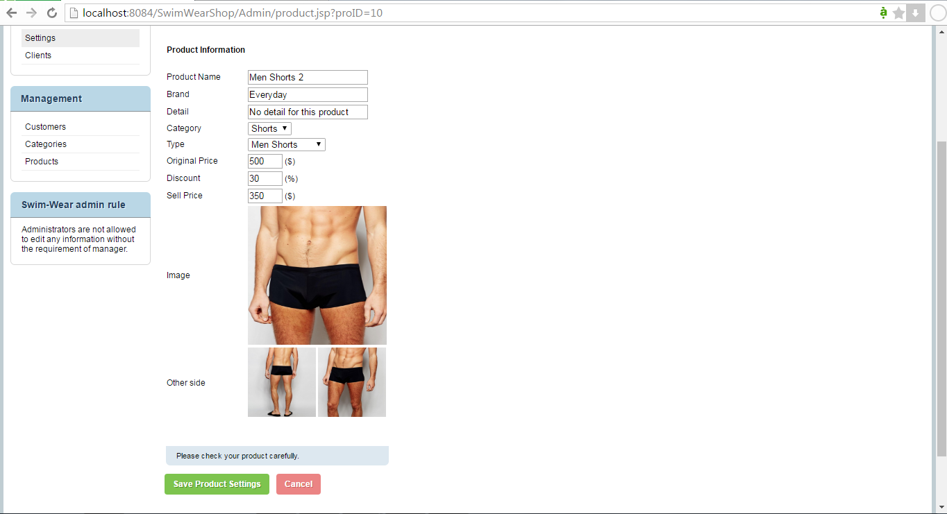

Finish user manual

>>>>Test Case<<<<

Test case 1.1 (simple)
Test case #: 1.1 | Test case name: register account
System: Swimming suit E-Commerce | Subsystem: database
Designed by: Nguyễn Hồng Hà | Design date: 17/12/2016
Executed by: Đỗ Hùng Cường | Execution date
Short description: test the register account function

Pre-conditions:
- The guess goes to the website.
- The guess needs to registers.
- The system displays the home page.

Step | Action | Expected System response | Pass/Fail | Comment
1 | Click the “Create account” button in the menu | The system display the page for inputting information for registering | Pass | No problem
2 | Input name, password (says “1234”), confirm password, email, bank account, address etc… | Display input information, password is encrypted. | Pass | No problem
3 | Click “Submit” | The system display “Account created” and automatically login. | Pass | No problem
4 | Check post-condition 1 |  | Pass | No problem

Post-conditions:
- The information on guess is saved in the database (first account)

Test case 1.2 (complex)
Test case #: 1.2 | Test case name: register account
System: Swimming suit E-Commerce | Subsystem: database
Designed by: Nguyễn Hồng Hà | Design date: 17/12/2016
Executed by | Execution date
Short description: test the register account function

Pre-conditions:
- The guess goes to the website.
- The guess needs to register.
- The system displays the register page.

Step | Action | Expected System response | Pass/Fail | Comment
1 | Click the “Create account” button in the menu | The system display the page for inputting information for registering | Pass | No problem
2 | Input name, password (says “1234”), confirm password, email, bank account, address, etc… | Display input information, password is encrypted. | Pass | No problem
3 | Click “Register” | The system checks invalid input. If none, the system displays “Account created”. | Pass | No problem
4 | Check post-condition 1 |  | Pass | No problem
5 | Repeat step 1-2, but using another text as a confirm password(says password is “1900” and confirm password is “321”) | Display input information, password is encrypted. | Pass | No problem
6 | Click “submit” | The system displays “wrong password, please re-enter confirm password”. | Pass | No problem
7 | Check post-condition 2 |  | Pass | No problem
8 | Enter confirm password correctly (says password and confirm password is “1900”) | Display input information, password is encrypted. | Pass | No problem
9 | Click “Register” | The system display “Account created”. | Pass | No problem
10 | Check post-condition 3 |  |  | No problem
11 | Repeat step 1-2, but leave one or more fields blank. | Display input information, password is encrypted. | Pass | Fixed
12 | Click “Submit” | The system displays “Please enter *the fields that are left blank*”. | Pass | Fixed
13 | Fill in all the blank filed | Display input information, password is encrypted. | Pass | No problem
14 | Click “Submit” | The system display “Account created”. | Pass | No problem
15 | Check post-condition 4 |  | Pass | No problem

Post-conditions:
- The information on guess is saved in the database (first account).
- Nothing changes in the system, no account is created.
- The second information of guess is saved in the database (second account).
- The third information of guess is saved in the database (third account).

Test case 2 (simple)
Test case #: 2 | Test case name: View Product information
System: Swimming suit E-Commerce | Subsystem: Database
Designed by: Nguyễn Hồng Hà | Design date: 17/12/2016
Executed by: Đỗ Hùng Cường | Execution date
Short description: test the View Product informtion

Pre-condition:
- Information of the product is stored in the database
- System displays home page.

Step | Action | Expected System response | Pass/Fail | Comment
1 | Click “Buy now” | The system displays the product page. | Pass | No problem
2 | Click on one product | The system displays the information of the chosen product. | Pass | No problem

Test case 3.1 (simple)
Test case #: 2.1 | Test case name: Search product
System: Swimming suit E-Commerce | Subsystem: Database
Designed by: Nguyễn Hồng Hà | Design date: 17/12/2016
Executed by: Đỗ Hùng Cường | Execution date
Short description: test the View Product informtion

Pre-condition:
- Information of the product is stored in the database.
- System displays home page.

Step | Action | Expected System response | Pass/Fail | Comment
1 | Click on “Search” icon | The system displays the search bar | Pass | No problem
2 | Type name of product you want to find in the website. | The system displays the input | Pass | No problem
3 | Click the icon “Search” | The system displays the result page, which contains product that has the name or part of the name the same as input name. And on the left, there is high function search. | Pass | No problem
4 | Check post-condition 1 |  | Pass | No problem

Post-condition:
- Check the database and displays result page which has the products that has the name matched the input value.

Step | Action | Expected System response | Pass/Fail | Comment
1 | Click on “Search” icon | The system displays the search bar | Pass | No problem
2 | Type name of product you want to find in the website. | The system displays the input | Pass | No problem
3 | Click the icon “Search” | The system displays the result page, which contains product that has the name or part of the name the same as input name. And on the left, there is high function search. | Pass | No problem
4 | Check post-condition 1 |  | Pass | No problem
5 | Repeat step 1-3, on high function search, choose category, type, price, discount | The system displays the input | Pass | No problem
6 | Click “search” | The system sorts out the results and displays products that match the input. | Pass | No problem
7 | Check post-condition 2 |  | Pass | No problem
8 | Repeat step 1-2, instead type random text on search bar (says “random thing”) | The system displays the input | Pass | Fixed
9 | Click “Search” | System displays “no result found” | Pass | Fixed
10 | Check post-condition 3 |  | Pass | Fixed

Post-condition:
- Check the database and displays result page which has the products that has the name matched the input value.
- Sort out the result and display the one that matches the high-functional input.
- Check the database, and display no result found if the input does not match.

Test case 3.1 (simple)
Test case #: 3.1 | Test case name: Login
System: Swimming suit E-Commerce | Subsystem: Database
Designed by: Nguyễn Hồng Hà | Design date: 17/12/2016
Executed by: Đỗ Hùng Cường | Execution date
Short description: test the login function

Pre-condition:
- Information of users is stored in the database.
- System displays home page.

Step | Action | Expected System response | Pass/Fail | Comment
1 | Click “log in” button | The system displays the login page | Pass | No problem
2 | Type correct email and correct password | The system displays the input | Pass | No problem
3 | Click “Login” | The system checks the database for register email and password that matches the email. Then the system displays home page with more functionality like cart, bank account, buy now, etc… | Pass | No problem
4 | Check post-condition 1 |  | Pass | No problem

Post-condition:
- Check the database for email and matching password, and displays customer page which has full functionality such as: cart, bank account, edit account, buy now, etc…

Test case 3.2 (complex)
Test case #: 3.2 | Test case name: Login
System: Swimming suit E-Commerce | Subsystem: Database
Designed by: Nguyễn Hồng Hà | Design date: 17/12/2016
Executed by: Đỗ Hùng Cường | Execution date
Short description: test the login function

Pre-condition:
- Information of users is stored in the database.
- System displays home page.

Step | Action | Expected System response | Pass/Fail | Comment
1 | Click “log in” button | The system displays the login page | Pass | No problem
2 | Type correct email and correct password | The system displays the input | Pass | No problem
3 | Click “Login” | The system checks the database for register email and password that matches the email. Then the system displays home page with more functionality like cart, bank account, buy now, etc… | Pass | No problem
4 | Check post-condition 1 |  | Pass | No problem
5 | Repeat step 1-2, but this time, type in unregistered email and password | The system displays the input |  | No problem
6 | Click “login” | The system checks database for email and matching password. There will be no existed email in the database. The system displays “wrong email and password” | Pass | No problem
7 | Check post-condition 2 |  | Pass | No problem
8 | Repeat step 1-2, this time, leave an empty filed in password, only type in email. | The system displays the input | Pass | No problem
9 | Click “login” | The system displays “Please type password” | Pass | No problem
10 | Repeat step 1-2, this time, leave an empty field in email, fill in password field | The system displays the input | Pass | No problem
11 | Click “login” | The system displays “Please type email” | Pass | No problem
12 | Repeat step 1-2, this time, type registered email, but enter wrong password | The system displays the input | Pass | No problem
13 | Click “login” | The system checks database for email and matching password. There will be un-matched password compared to the valid email. The system displays “wrong password, please re-enter password” | Pass | No problem
14 | Check-post condition 3 |  | Pass | No problem

Post-condition:
- Check the database for email and matching password, and displays customer page which has full functionality such as: cart, bank account, edit account, buy now, etc…
- Check the database for email and matching password, there’s no email matched, display email and password not match.
- Check the database for email and matching password, password does not match the given valid email, display wrong password.

Test case 4 (simple)
Test case #: 4 | Test case name: Logout
System: Swimming suit E-Commerce | Subsystem: Database
Designed by: Nguyễn Hồng Hà | Design date: 17/12/2016
Executed by: Đỗ Hùng Cường | Execution date
Short description: test the logout function

Pre-condition:
- Users have logged in to the system.

Step | Action | Expected System response | Pass/Fail | Comment
1 | Click “logout” button | The system return to home page. And hide some buttons such as: cart, bank account, buy now, etc… | Pass | No problem

Test case 5.1 (simple)
Test case #: 5.1 | Test case name: add/remove product from cart
System: Swimming suit E-Commerce | Subsystem: Database
Designed by: Nguyễn Hồng Hà | Design date: 17/12/2016
Executed by: Đỗ Hùng Cường | Execution date
Short description: test the add/remove product from cart function

Pre-condition:
- Users have logged in to the system
- Information on the system is stored in the database
- The system display the product page

Step | Action | Expected System response | Pass/Fail | Comment
1 | Click on the product | The system display the chosen product page | Pass | No problem
2 | Choose the quantity (says “3”) | Display input “3” | Pass | No problem
3 | Click “add to cart” | The system displays number “3” along with the total cost in the cart button, to show that there are items have been chosen. | Pass | No problem
4 | Repeat step 1-3 with another product | The system displays chosen number along with the total cost in the cart button, to show that there are new items have been added | Pass | No problem
5 | Click on “cart” button | The system display cart page | Pass | No problem
6 | Click “remove” button | The system delete the product you choose to remove (remove all the quantity of the chosen product) displays the change in the cart page, and displays the recalculated total cost. | Pass | No problem
6 | Check post-condition 1 |  | Pass | No problem

Post-condition:
- The system displays the total product quantity and the total cost.

Test case 5.2 (complex)
Test case #: 5.2 | Test case name: add/remove product from cart
System: Swimming suit E-Commerce | Subsystem: Database
Designed by: Nguyễn Hồng Hà | Design date: 17/12/2016
Executed by: Đỗ Hùng Cường | Execution date
Short description: test the add/remove product from cart function

Pre-condition:
- Users have logged in to the system
- Information on the system is stored in the database
- The system display the product page

Step | Action | Expected System response | Pass/Fail | Comment
1 | Click on the product | The system display the chosen product page | Pass | No problem
2 | Choose the quantity (says “3”) | Display input “3” | Pass | No problem
3 | Click “add to cart” | The system displays number “3” along with the total cost in the cart button, to show that there are items have been chosen. | Pass | No problem
4 | Repeat step 1-2 with another product | The system displays chosen number along with the total cost in the cart button, to show that there are new items have been added | Pass | No problem
5 | Click on “cart” button | The system display cart page | Pass | No problem
6 | Click “remove” button | The system delete the product you choose to remove (remove all the quantity of the chosen product) displays the change in the cart page, and displays the recalculated total cost. | Pass | No problem
7 | Check post-condition 1 |  | Pass | No problem
8 | Repeat step 1-2, but this time input the negative number for quantity | The system displays “wrong input, please choose quantity higher or equal to one” | Pass | No problem
9 | Check post-condition 2 |  | Pass | No problem
10 | Repeat step 1-2, but the user didn’t login | The system doesn’t show add to cart button | Pass | Fixed
11 | Check post-condition 3 |  | Pass | Fixed
12 | Repeat step 1-3, then click “Empty cart” | The system deletes all the chosen products in the cart and total cost is reset to zero. Later the system doesn’t display anything in the cart. | Pass | Fixed
13 | Check post-condition 4 |  | Pass | Fixed

Post-condition:
- The system displays the total product quantity and the total cost.
- The cart doesn’t change, no product is added
- The system doesn’t show add to cart function, no product is added
- The system deletes all the product information in the cart. No product is recorded to the view transaction.

Test case 6.1
Test case #: 6.1 | Test case name: edit profile
System: Swimming suit E-Commerce | Subsystem: database
Designed by: Đỗ Hùng Cường | Design date: 17/12/2016
Executed by: Nguyễn Hồng Hà | Execution date
Short description: test the edit profile function

Pre-conditions:
The user goes to the website.
The user had logged into system
The system displays the profile page.

Step | Action | Expected System response | Pass/Fail | Comment
1 | User goes to profile page | The system display the profile page | Pass | No problem
2 | Input name, address, password, confirm password and click “Edit” button | The system check for invalid input, if something invalid, system show message which is invalid, else system display the profile page with new customer’s profile and show message “edit successfully” | Pass | No problem
3 | Check post-condition 1

Post-conditions:
- The information on user is save in the database.

Test case 6.2:
Test case #: 6.2 | Test case name: edit profile
System: Swimming suit E-Commerce | Subsystem: database
Designed by: Đỗ Hùng Cường | Design date: 17/12/2016
Executed by: Nguyễn Hồng Hà | Execution date
Short description: test the edit profile function

Pre-conditions:
The user goes to the website.
The user had logged into system
The system displays the profile page.

Step | Action | Expected System response | Pass/Fail | Comment
1 | User goes to profile page | The system display the profile page | Pass | No problem
2 | Input name, address, password, confirm password and click “Edit” button | The system check for invalid input, if something invalid, system show message which was invalid, else system displays the profile page with new customer’s profile and shows message “edit successfully” | Pass | No problem
3 | Check post-condition 1 |  | Pass | No problem
4 | Repeat steps 1,2 but input password different from confirm password | The system show message “password do not match” | Pass | No problem
5 | Check post-condition 2 |  | Pass | No problem
6 | Change the confirm password the same as the password | The system check for invalid input, if something invalid, system show message which is invalid, else system display the profile page with new customer’s profile and show message “edit successfully” | Pass | No problem
7 | Check post-condition 1 |  | Pass | No problem
8 | Repeat steps 1,2, 5 but do not click “edit” button but click on another page link | The system show another page that customer clicked | Pass | No problem
9 | Check post-condition 2 |  | Pass | No problem

Post-conditions:
- The information of user is updated to the database.
- The information of user is not updated to the database.

Test case 7.1
Test case #: 7.1 | Test case name: pay bill
System: Swimming suit E-Commerce | Subsystem: database
Designed by: Đỗ Hùng Cường | Design date: 17/12/2016
Executed by: Nguyễn Hồng Hà | Execution date
Short description: test the pay bill function

Pre-conditions:
- The user goes to the website.
- The user had logged into system
- The system displays the shopping cart page.

Step | Action | Expected System response | Pass/Fail | Comment
1 | Customer goes to shopping cart page | The system display the shopping cart page  and display all the orders that customer add to shopping cart | Pass | No problem
2 | Customer click on “pay” button without order anything in the shopping cart | system will ask customer to order something | Pass | No problem
3 | Check post-condition 2 |  | Pass | No problem
4 | Order one product to cart then repeat steps 1,2 and click “pay” button | system display “payment successful” | Pass | No problem
5 | Check post-condition 1 |  |  | No problem

Post-conditions:
- The bill is updated as a transaction of the current customer
- The bill is not updated as a transaction of the current customer

Test case 7.2:
Test case #: 7.2 | Test case name: pay bill
System: Swimming suit E-Commerce | Subsystem: database
Designed by: Đỗ Hùng Cường | Design date: 17/12/2016
Executed by: Nguyễn Hồng Hà | Execution date
Short description: test the pay bill function

Pre-conditions:
- The user goes to the website.
- The user had logged into system
- The system displays the shopping cart page.

Step | Action | Expected System response | Pass/Fail | Comment
1 | Customer goes to shopping cart page | The system display the shopping cart page  and display all the orders that customer add to shopping cart | Pass | No problem
2 | Customer click on “pay” button without order anything in the shopping cart | system will ask customer to order something | Pass | No problem
3 | Check post-condition 2 |  | Pass | No problem
4 | Order one product to cart then repeat steps 1,2 and click “pay” button | system display “payment successful” | Pass | No problem
5 | Check post-condition 1 |  | Pass | No problem
4 | Add 100000 orders to cart then repeat steps 1,2 and click pay “button” | The system will display “not enough money to pay” | Pass | Fixed
5 | Check post-condition 2 |  | Pass | Fixed

Post-conditions:
- The bill is updated as a transaction of the current customer
- The bill is not updated as a transaction of the current customer

Test case 8 (simple)
Test case #: 8 | Test case name: View transaction
System: Swimming suit E-Commerce | Subsystem: Database
Designed by: Nguyễn Hồng Hà | Design date: 17/12/2016
Executed by: Đỗ Hùng Cường | Execution date:
Short description: test the view transaction function

Pre-condition:
- The users have logged in to the website.
- The user have made some transactions
- The system displays product page

Step | Action | Expected System response | Pass/Fail | Comment
1 | Click “Transaction link” | The system checks the transaction in the database, displays information on the product in Transaction page including: name of product, quantity, price, purchase date and time. | Pass | No problem

Test case 9.1:
Test case #: 9.1 | Test case name: update product
System: Swimming suit E-Commerce | Subsystem: database
Designed by: Đỗ Hùng Cường | Design date: 17/12/2016
Executed by: Nguyễn Hồng Hà | Execution date
Short description: test the update product function

Pre-conditions:
- The user goes to the website.
- The user had logged into system
- The system displays the update product page.

Step | Action | Expected System response | Pass/Fail | Comment
1 | Admin goes to the update product page | The system display the update product page with all the products and their information | Pass | No problem
2 | Admin click on delete symbol button beside the product information | The system delete the products form the list of products | Pass | No problem
3 | Check post-condition 1 |  | Pass | No problem
4 | Repeat steps 1 but click on edit symbol button beside the product information | The system display the edit product page and show all information for admin in a textbox for admin to edit product’s name, detail, brand, price, discount or combo box for admin to select category and type. | Pass | No problem
5 | Admin input wrong product’s name format or input the word or the negative number for price or the percent of discount inputted is smaller than 0 or greater than 100 and click “save” button | System show message that the input is incorrect then admin will input again | Pass | No problem
6 | Check post-condition 2 |  | Pass | No problem
7 | Repeat steps 1 but click on add new product button below the table contains list of product | The system display the add new product page and show empty textbox for admin to input new product’s name, detail, brand, price, discount or combo box for admin to select category and type. | Pass | No problem
8 | Similar to steps 5 | System show message that the input is incorrect then admin will input again | Pass | No problem
9 | Check post-condition 3 |  | Pass | No problem
10 | Repeat steps 1 and click on select all button | System check all the checkbox beside the product with match to this product | Pass | No problem
11 | Repeat steps 1 and deselect button | System deselect all the checkbox which is checked beside the product with match to this product | Pass | No problem
12 | Check some checkbox beside some products and click delete selected | System delete all the products which checkbox is selected from the list of product | Pass | No problem
12 | Check post-condition 4 |  | Pass | No problem

Post-conditions:
- The product is deleted from the database system.
- The new product information is not updated to the database.
- The new product is not inserted to the database system.
- The list of products that is checked is deleted fom database.

Test case 9.2:
Test case #: 9.2 | Test case name: update product
System: Swimming suit E-Commerce | Subsystem: database
Designed by: Đỗ Hùng Cường | Design date: 17/12/2016
Executed by: Nguyễn Hồng Hà | Execution date
Short description: test the update product function

Pre-conditions:
- The user goes to the website.
- The user had logged into system
- The system displays the update product page.

Step | Action | Expected System response | Pass/Fail | Comment
1 | Admin goes to the update product page | The system display the update product page with all the products and their information | Pass | No problem
2 | Admin click on delete symbol button beside the product information | The system delete the products form the list of products | Pass | No problem
3 | Check post-condition 1 |  | Pass | No problem
4 | Repeat steps 1 but click on edit symbol button beside the product information | The system display the edit product page and show all information for admin in a textbox for admin to edit product’s name, detail, brand, price, discount or combo box for admin to select category and type. | Pass | Fixed
5 | Admin input edit the value and click “save” button | System show message “edit successfully” | Pass | Fixed
6 | Check post-condition 2 |  | Pass | Fixed
7 | Repeat steps 1 but click on add new product button below the table contains list of product | The system display the add new product page and show empty textbox for admin to input new product’s name, detail, brand, price, discount or combo box for admin to select category and type. | Pass | Fixed
8 | Admin input new value and click “add new product” button | System show message “create new product successfully” | Pass | Fixed
9 | Check post-condition 3 |  | Pass | Fixed

Post-conditions:
- The product is deleted from the database system.
- The new product information is updated to the database.
- The new product is inserted to the database system

Test case 10
Test case #: 10 | Test case name: Manage Customer
System: Swimming suit E-Commerce | Subsystem: database
Designed by: Đỗ Hùng Cường | Design date: 17/12/2016
Executed by: Nguyễn Hồng Hà | Execution date
Short description: test the manage customer function

Pre-conditions:
- The user goes to the website.
- The user had logged into system
- The system displays the customer management page.

Step | Action | Expected System response | Pass/Fail | Comment
1 | Admin goes to customer management page. | The system display the customer management page and display all customers account which contains customer’s name, email, password, address, bank account from database system | Pass | No problem
2 | Admin goes to click on view transaction symbol button beside the customer information | system display this customer’s transaction page and show the table of transaction that contains the products, quantity, total payment, date and time. | Pass | No problem

Reference
- Vision and scope document
- System requirement specification document
- System design specification document
- Project Plan document
- Test case Template – Dr Ghazy Assassa

